**CLIENT PROFILE IN GUI**

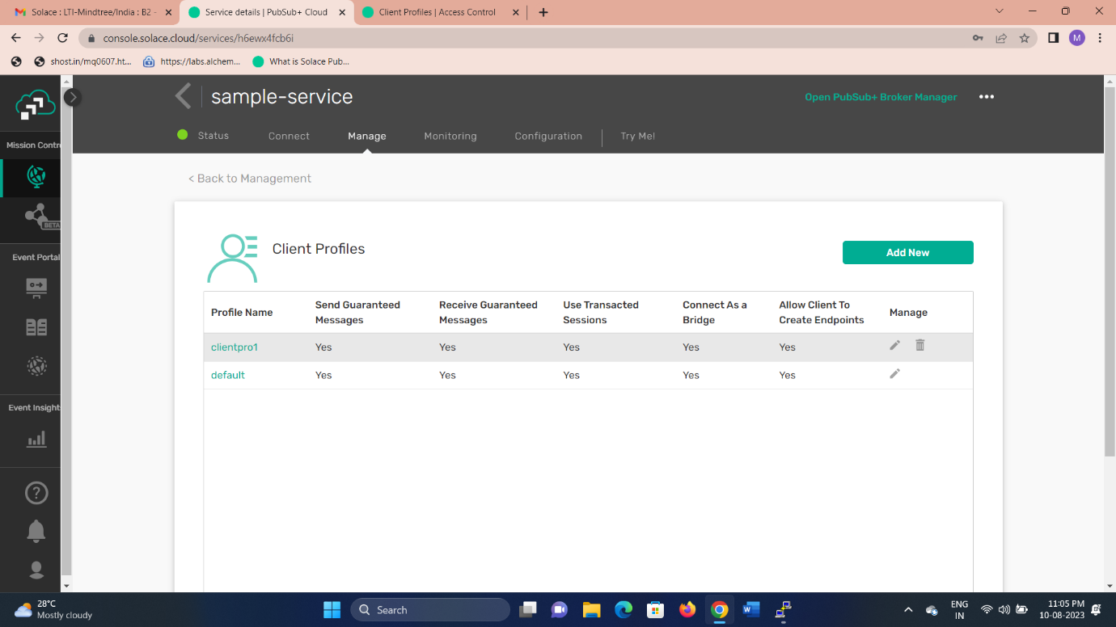

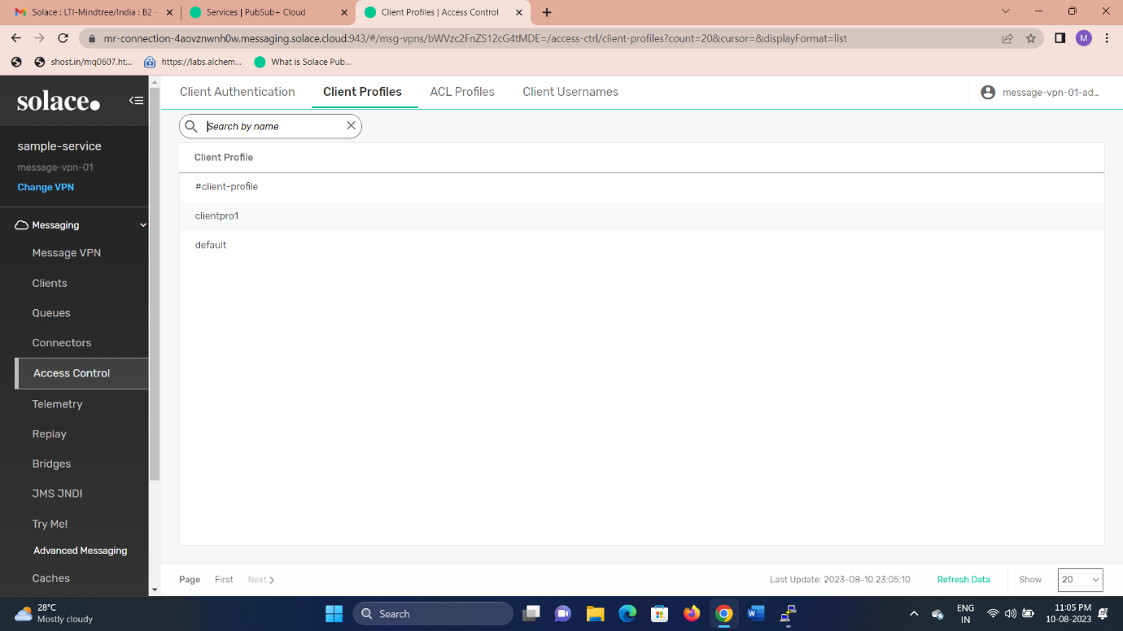

**CLIENT-PROFILE BIND WITH THE CLIENT USERNAME**

